2008 Annual Report on Germanium Market 1 Properties, usages, distributions of germanium

* 1. Germanium properties

Germanium is a silvery-gray, brittle metal, albeit some people also calling it a semi-metal,

which has a bright luster. It was discovered in 1886 by a Gennany chemist. Its melting point is at 937 .4 'C, boiling point at 2830 ·c and density around 5.35g/crn3 •

Gennanium is contained with zinc ores, other sulfide ore minerals and coals. The average germanium content in zinc deposits from which it is recovered ranges from 0.01 % to 0.1 %, while that in coals differs from 0.001 % to 0.1 %.

* 1. Germanium usages

Germanium used in fiber-optic systems accounts for 24% of the worldwide consumption, polymerization catalysts, 31%; infrared optics, 23%; solar electric applications, 12%; and others (phosphors, metallurgy and chemotherapy), 10%.

However, the situation differs with countries. For example, Japan uses germanium mainly as the polymerization catalysts, while such applications are rare in America, where germanium is mainly consumed in fiber-optic systems (40% of the American consumption), infrared optics (30%) and solar cell applications (20%).

Worldwide germanium consumptions

Solar cells 12%

Infra.red optics 23%

* 1. Germanium distributions in China

Fiber optics 24%

PET catalysts 31%

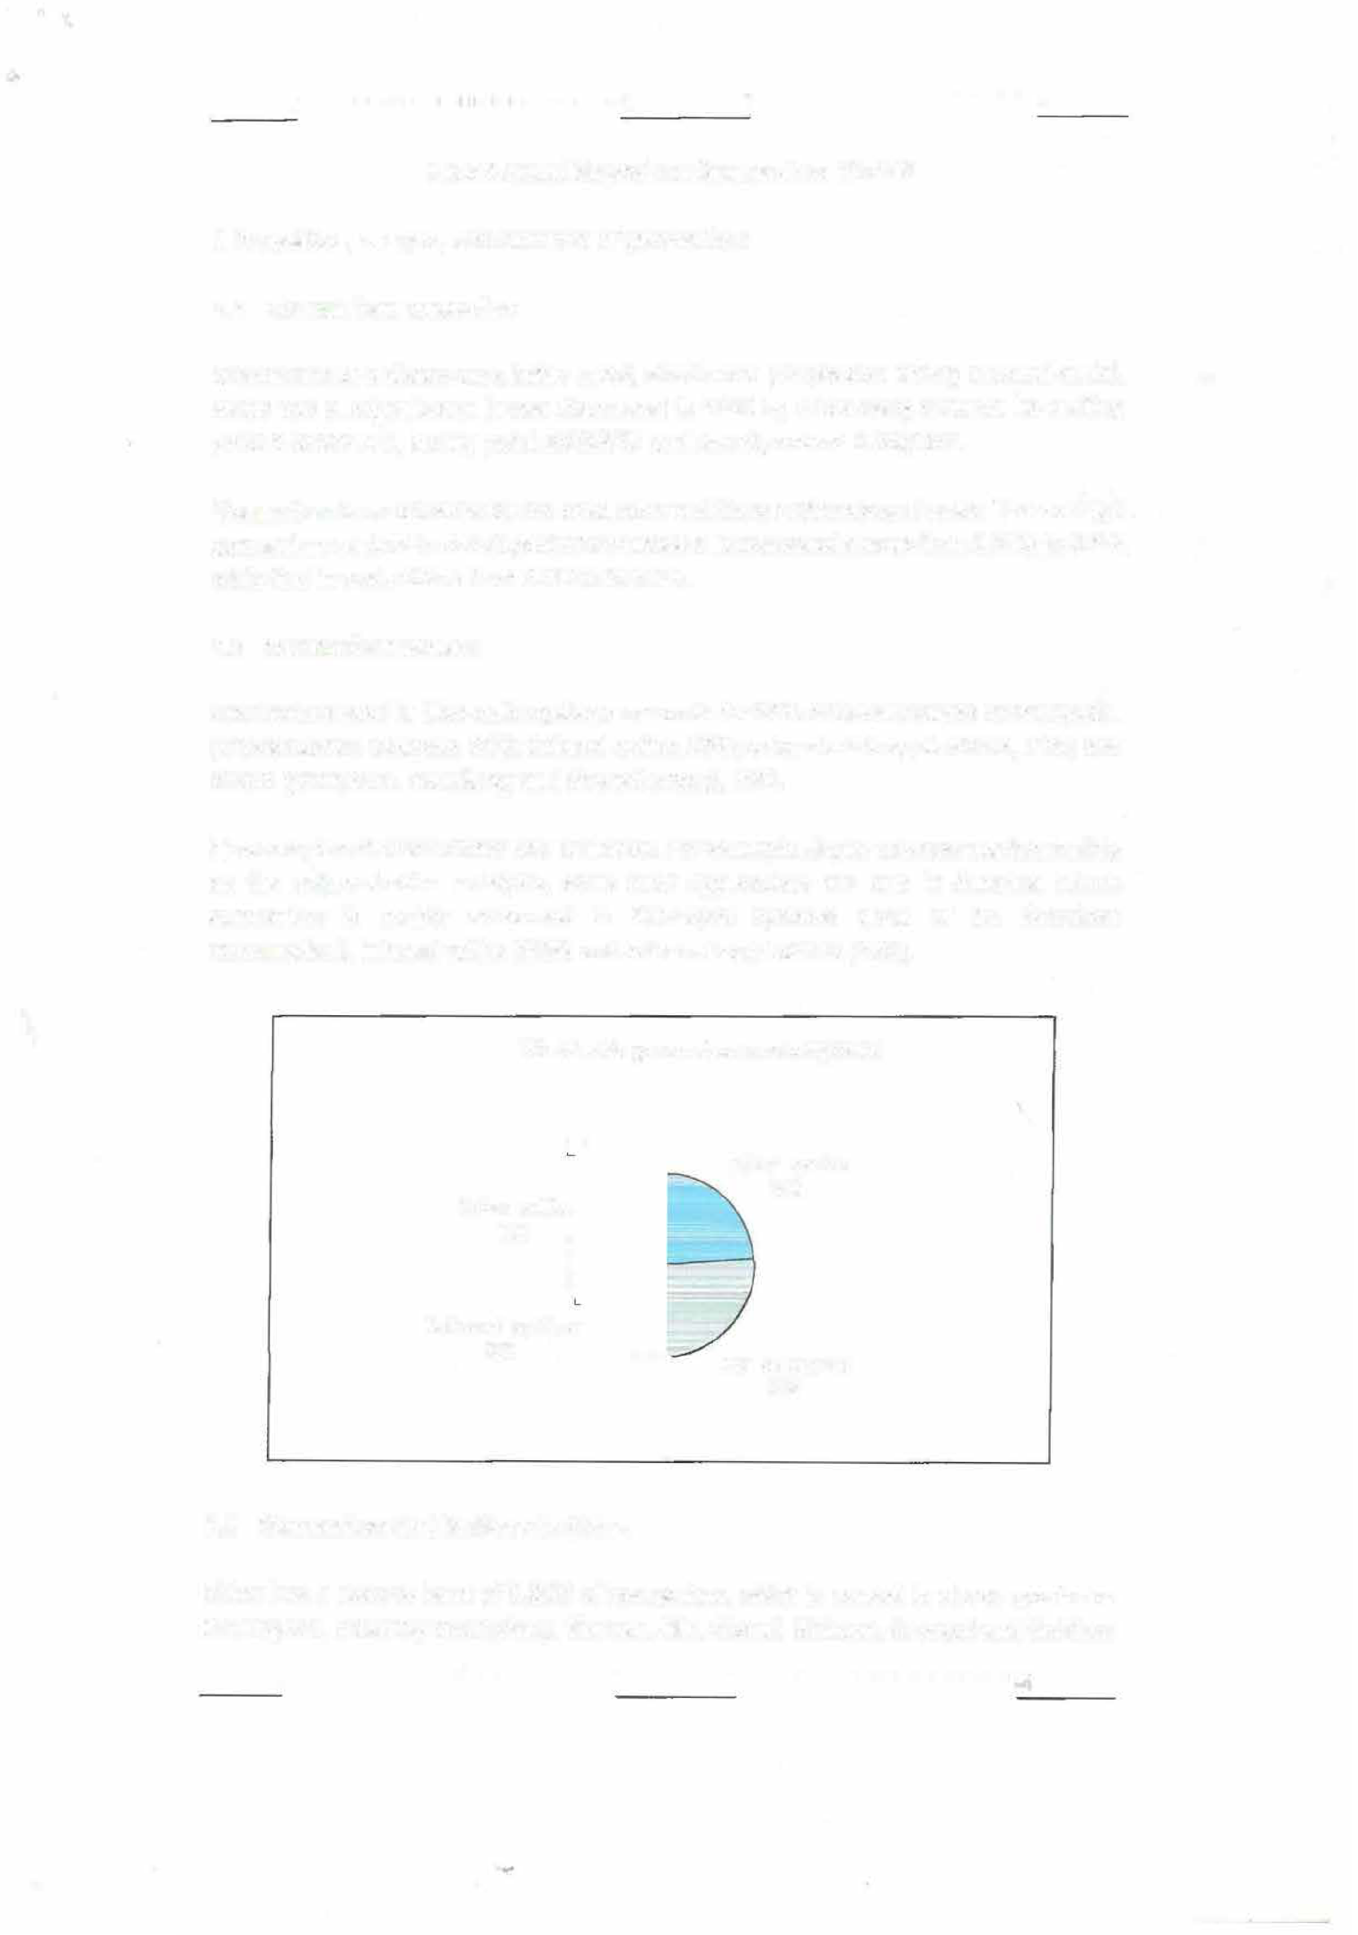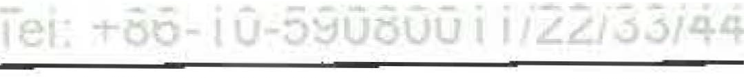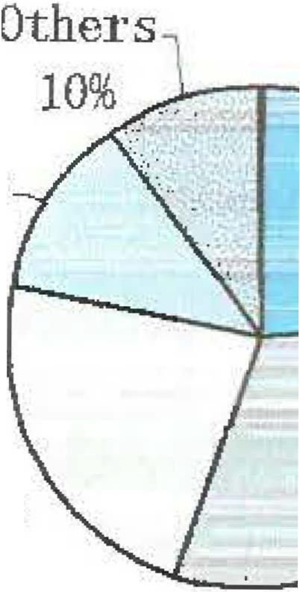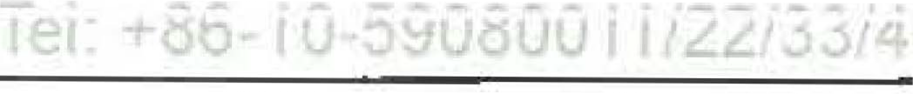

China has a reserve base of 3,055t of germanium, which is spread in eleven provinces and regions, including Guangdong, Yunnan, Jilin, Shanxi, Sichuan, Guangxi and Guizhou

Task/Program:

Date and Time of Analysis: Type of Analysis:

Number of Repeats: Cassette Number:

BCU/REVSLAG 5/23/2009 0:44:46

Concentration Analysis

1

5

Sample Name: RSl Sample Number: RSl

Run Avg>

CuKal,2 1.7224

PbLbla 0.7842

ZnKal,2a 1.1507

AsKbl,3 2.0375

FeKal,2 30.8699

SiKal,2

29.4550

CaKal,2a 2.6075

SKa1,2a 3.4930

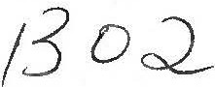

Task/Program:

Date and Time of Analysis: Type of Analysis:

Number of Repeats:

Cassette Number:

BCO/REVSLAG 5/23/2009 0:46:48

Concentration Analysis

1

6

Sample Name:

RS2

Sample Number:

RS2

Run Avg>

CuKal,2

1.7081

PbLbla 0.7737

ZnKal,2a 1.1513

AsKbl,3 2.0123

FeKal,2 30.5901

SiKal,2

29.8542

CaKal,2a 2.6715

SKal,2a 3.3969

Task/Program:

Date and Time of Analysis: Type of Analysis:

Number of Repeats: Cassette Number:

AGDIK/RS 5/23/2009 0:48:24

Intensity Measurement

1

6

Sample Name:

Run AlKal,2 Avg> 11.0239

MgKal,2 10.5143

RS2

Sample Number:

RS2





j



provinces. Germanium reserves in the above provinces take an account of 96% in the total amount.

# Market Review

With global economic crisis spreading across the world from the fourth quarter of 2008, both producers and consumers hold a wait-and-see attitude towards the germanium market. Except for some long-term contracts having been signed before, new orders are seldom sealed. Few inquiries in the market and panic sentiments from participants cause the price to go down, which makes consumers continue to watch the market, which explains why there were few deals in the fourth quarter. The germanium market was deadlocked in December 2008, and the price trend may be clear next year.

# Germanium metal market review

**:.:ar** 1111



China germanium metal export price • Germanium metal price in Europe Germanium metal price in China

1-4 2-15 3-21 4-30 6-6 7-11 8-20 9-24 11-5 12-10

11500

11000

10500

10000

9500 o::

C

9000 ::,

8500

8000

0111111111111111111111 II Ill II 111111111111JI11111111111111111111111111111II11111111111111111ti

400

200

:

**II**

r

l

l

1400

1800

1600

Germanium metal price curws in 2008

t

8600

1000t

*[l* 1200

(Source: Asian Metal)

China germanium metal price was relatively stable in the first quarter in 2008 and it rose slightly in March. Germanium metal export price keeps stable at around USD1,300-1,320/kg from January to February, but went up to around USD1,380-1,400/kg late March as some Chinese suppliers increased offers.

Germanium metal price kept rising in the second quarter, eventually up to around USD1,600-1,620/kg in May. The main reasons for the continuous price increase were the tight supply in the market and Chinese suppliers continuing to increase their offers. However, the price remained stable in June, rather than continuously going up, because some zinc producers started to sell germanium dioxide inventories when zinc price began to drop, which helped ease up the supply shortage.

The price began to fall from USD1,600-1,620/kg to USD1,580-1,600/kg in the third quarter,

Task/Program:

Date and Time of Analysis: Type of Analysis:

Number of Repeats: Cassette Number:

BCU/DIPSLAG 5/23/2009 0:37:52

Concentration Analysis

1

5

Sample Name: RSl Sample Number: RSl

Run Avg>

CuKal,2 1.6010

PbLbla

0.1993

ZnKal,2a 1.1432

AsKbl,3 0.6369

FeKal,2 35.3733

SiKal,2 26.7361

CaKal,2a 4.4173

SKal,2a 2.5555

Task/Program:

Date and Time of Analysis: Type of Analysis:

Number of Repeats: Cassette Number:

BCU/DIPSLAG 5/23/2009 0:39:52

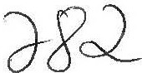Concentration Analysis

1

6

Sample Name:

RS2

Sample Number:

RS2

Run Avg>

CuKal,2

1.5913

PbLbla 0.1976

ZnKal,2a

1.1398

AsKbl,3

0.6384

FeKal,2 35.3840

SiKal,2 26.9757

CaKal,2a 4.4095

SKal,2a 2.5149

Task/Program:

Date and Time of Analysis:

|  |  |  |
| --- | --- | --- |
| Type of Analysis: |  | Intensity Measurement |
| Number of Repeats: |  | 1 |
| Cassette Number:  Sample Name: | RS2 | 6  Sample Number: RS2 |

AGDIK/RS 5/23/2009 0:41:28

Run Avg>

AlKal,2 5.2340

MgKal,2 5.8038





few deals were concluded in the market during the summer holiday in western countries. The market remained inactive in September, when foreign consumers finished their summer vacation and the export price fell to around USD1,560-1,580/kg.

Few deals were concluded in germanium metal market in the fourth quarter, and the price declined considerably in October and November from USD1,560-1,580/kg to USD1,330-1,350/kg, down by around 15%. The price stayed at the above level in December, and consumers ere holding a wait-and-see attitude while producers were reluctant to lower offers, making the market stagnant.

* + - 1. **Germanium oxide market review**



Germanium oxide price CUMS in2008

1200

1000 [I •= **··:-t;;_,...,a-111. IF!llfl'fl'k...**

**UIIIIII**■**••**

*l* soo

0

600

-

*§* 400

200

8000

7000

6000

O>

5000

4000

3000

:::>

2000

1000

0

Jan Feb Apr Miy Jul *Pug* Sep Nov Dec

China germanium oxide export price -+ China germanium oxide price

(Source: Asian Metal)

Chinese government started to impose 5% export duty on germanium oxide (HS Code: 28256000) from 1st Jan 2008, so Chinese exporters raised offers from USD870-890/kg to USD930-950/kg at the beginning of January, and kept increasing it to around USD1,030-1,050/kg during April and May though Japanese consumers were unwilling to make purchases at thess high prices.

However, there was increasing germanium oxide supply in the spot market in June. Some Zinc producers were forced to sell germanium oxide inventories as zinc price kept falling, so the supply of germanium oxide began to increase and the price increase of germanium dioxide slowed down. The price of zinc 99.995% min was around at the beginning of January, 2008, and from then on it kept dropping and declined to around RMB16,000-16,100/t late May, down by 16% in a period of five months. Some zinc producers increased the sales volume of germanium oxide to make up the losses.

Germanium oxide price began to fall from USD1, 030-1,050/kg in July, and then, affected by the economic crisis, it dropped to around USD800-820/kg in the middle of November, remaining stable in December as Chinese suppliers were reluctant to lower offers, leaving

Task/Program:

Date and Time of Analysis: Type of Analysis:

Number of Repeats: Cassette Number:

BCU/DIPSLAG 5/23/2009 1:26:20

Concentration Analysis

1

5

Sample Name: RSl Sample Number: RSl

Run Avg>

CuKal,2 2.2475

PbLbla 0.2046

ZnKal,2a 1,0744

AsKbl,3 0.6075

FeKal,2 35.1504

SiKal,2 23.3779

CaKal,2a 2.8481

SKal,2a 3.7116

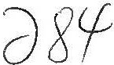

Task/Program:

Date and Time of Analysis: Type of Analysis:

Number of Repeats: Cassette Number:

BCU/DIPSLAG 5/23/2009 1:28:20

Concentration Analysis

1

6

Sample Name:

RS2

Sample Number:

RS2

Run Avg>

CuKal,2 2.2526

PbLbla 0.2023

ZnKal,2a 1.0655

AsKbl,3

0. 6161

FeKal,2 35.1042

SiKal,2 23.3398

CaKal,2a 2.7595

SKal,2a 3.7490

Task/Program:

Date and Time of Analysis: Type of Analysis:

Number of Repeats:

Cassette Number:

AGDIK/RS 5/23/2009 1:29:56

Intensity Measurement 1

6

Sample Name:

RS2

Sample Number:

RS2

Run Avg>

AlKal,2

4. 94 08

MgKal,2 5.2790

Task/Program:

Date and Time of Analysis: Type of Analysis:

Number of Repeats: Cassette Number:

HCR/HCR

5/23/2009 1:30:50

Concentration Analysis

1

5

Sample Name:

RSOl

Sample Number:

RS02

Run SiKal,2 Avg> 34.0252

Task/Program:

Date and Time of Analysis: Type of Analysis:

Number of Repeats: Cassette Number:

HCR/HCR

5/23/2009 1:31:24

Concentration Analysis

1

6

Sample Name: RS02 sample Number: RS02

Run SiKal,2 Avg> 34.2429





44

* + 1. **Production situation in China**

Unit tons

|  |  |  |  |
| --- | --- | --- | --- |
| Products | 03 outputs | 04 outputs | Total outputs in 2008 |
| Germanium oxide | 10.1 | **9.4** | 36.2 |
| Germanium metal | 10.9 | **8.8** | 37.7 |
| Germanium nomocrystalline | **3.4[R]** | **3.4** | **12.4** |

( Notes: Germanium oxide output have been converted to germanium metal volumes; R means that the date has been revised.)

China produced 86.3 tons of germanium products in 2008, but consumers chose to watch the market in the fourth quarter due to the economic crisis, without too many purchases in the spot market, so germanium oxide output decreased in the fourth quarter.

* + 1. **Germanium applications**
       1. **Germanium oxide used as a catalyst in producing PET bottles**

Germanium oxide, used as a PET catalyst, is mainly exported to Japan. lt is reported that Japanese customers may use antimony trioxide instead of germanium oxide. However, Chinese insiders think that the replacement cannot be achieved in a short time as antimony trioxide catalyst could release hazardous substances when heated.

* + - 1. **Germanic tetrachloride used in fiber-optic communication**

Fiber-optic communication is the foundation of the information age. Optical grade germanium tetrachloride ( i.e., high purity germanium tetrachloride) had been developed since 1973 in order to meet the need of fiber-optic production. Germanium used in fiber-optic communication mainly seives as fiber-optic and photoelectric conversion. As the operating wavelength of fiber-optic communication should be within the infrared range, germanium-doped silica fiber is regarded to be the best when considering the performance (refractive index, coefficients of expansion) after the research of all other extra-long wave infrared fiber-optic materials. In terms of performance parameters, such as loss coefficients, the superiority of the germanium-doped silica fiber cannot be matched. Germanium tetrachloride is considered to be the best materials used in fiber optic communication.

With the copper price rising while optical fiber price dropping, optical fiber cable has an incomparable advantage compared with copper cable in the aspect of transmission speed and transmission capability, so it may be a new substitute, which will bring great opportunities for optical fiber cable industry.

* + - 1. **Germanium metal used in infrared optical sector**

Germanium metal is wildly used in infrared optical sector, mainly applied to national





Task/Program:

Date and Time of Analysis: Type of Analysis:

Number of Repeats: Cassette Number:

BCU/DIPSLAG 5/22/2009 23:47:16

Concentration Analysis

l

5

Sample Name: RSl Sample Number: RSl

Run Avg>

CuKal,2 1.5885

PbLbla 0.1851

ZnKal,2a 1.1533

AsKbl,3 0.5687

FeKal,2 35.7551

SiKal,2 29.0427

CaKal,2a 5.0198

SKal,2a 1.9404

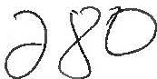

Task/Program:

Date and Time of Analysis: Type of Analysis:

Number of Repeats: Cassette Number:

BCU/DIPSLAG 5/22/2009 23:49:16

Concentration Analysis

1

6

Sample Name:

RS2

Sample Number:

RS2

Run Avg>

CuKal,2 1.6139

PbLbla 0.1883

ZnKal,2a

1 .1 711

AsKbl,3 0.5773

FeKal,2 35.6831

SiKal,2 28.9477

CaKa1,2a 5.2193

SKal,2a 1.9002

Task/Program:

Date and Time of Analysis:

|  |  |  |
| --- | --- | --- |
| Type of Analysis: |  | Intensity Measurement |
| Number of Repeats: |  | 1 |
| Cassette Number:  Sample Name: | RS2 | 6  Sample Number: RS2 |

AGDIK/RS

5/22/2009 23:50:50

Run Avg>

AlKal,2 4.8802

MgKal,2 5.5550

Task/Program:

Date and Time of Analysis: Type of Analysis:

Number of Repeats: Cassette Number:

BCU/MATTE

5/22/2009 23:53:44

Concentration Analysis

1

3

Sample Name:

CMOl Sample Number:

Run Avg>

CuKal,2a 51.9674

AsKbl,3

0. 4675

PbLbla 0.5897

SKal,2a 23.7729

ZnKal,2a 0.5580

FeKal,2 21.3570

AgKal,2 0.0227

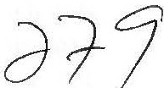

Task/Program:

Date and Time of Analysis: Type of Analysis:

Number of Repeats: Cassette Number:

BCU/MATTE 5/22/2009 23:56:14

Concentration Analysis

1

4

Sample Name:

CM02

Sample Number:

Run Avg>

CuKal,2a 52.0510

AsKbl,3

0. 47 64

PbLbla 0.5913

SKal,2a 23.6454

ZnKal,2a 0.5574

FeKal,2 21.3272

AgKal,2 0.0228



defense equipments. The atmospheric transmissivity of germanium is high and homogeneous because it is within the 2~14 micron infrared band where the infrared ray has the highest transparency in the aerosphere. Therefore, it is an irreplaceable infrared optical material. Meanwhile, germanium has lots of prominent dominance, such as chemical stability, corrosion-resistant and easily processed. Germanium could be made into germanium single crystal, and sliced up to make germanium lens and germanium windows. Germanium single crystal could be made into infrared optical components because of the characteristic of long wavelength when permeating infrared optical, which is wildly used in all kinds of infrared optical system, such as thermal infrared imager and night-vision goggles, photo detector, infrared detectors, missiles, lasers, infrared radar microwave tubes and microwave integrated circuits.

In the aspect of germanium used in national defense equipments, the demand for germanium depends on the update of national defense equipment, and may increase with the update term arriving.

* + - 1. **Germanium single crystal used in solar cell industry**

With the unique trait of high radioresistance, high frequency, good photoelectric properties, high purity germanium single crystal is wildly used in the high-tech fields, such as energy sources, photoelectricity, national defense, aviation and IT industry. Compound semiconductors on germanium substrate battery with its trait of high efficiency, high voltage, and high temperature has been wildly used in satellite solar cell, radar station for national defense in remote and border areas and microwave communication stations.

After Si, GaAs, lnP solar battery, 111-V compound thin-film epitaxially grown on germanium substrate solar cells (namely (GalnP/GaAs/Ge) monocrystalline thin-film three-junction solar celO is the fourth generation product whose highest photoelectric conversion efficiency could achieve 28%-32% under industrialization, and the germanium monocrystalline with dislocation density { 103/cm2) is the major substrate material to produce satellite solar cell. It is reported that with the development of photoelectric conversion efficiency of germanium monocrystalline used in solar battery, solar energy photovoltaic field becomes another growing market where germanium could be applied to.

* + - 1. **Gennanium used in new technology fields**

SiGe compound has been applied to CMOS chips and transistors because it makes CMOS chips and transistors smaller, reduces electronic noise produced by themselves, extends battery life, and assures stability under the extra **HF** condition. IBM has announced that they have produced SiGe chips operating at room temperature with frequency nearly 350GHz. In the areas of wireless communication, we have substituted SiGe compound for GaAs; Si chips producers have produced low cost and industrialized SiGe chips. Scientists are now doing research into the germanium insulating substrate material which can replace silicon metal in a small chips and LED products based on germanium.

0



Task/Program:

Date and Time of Analysis: Type of Analysis:

Number of Repeats: Cassette Number:

BCU/DIPSLAG 5/23/2009 5:28:20

Concentration Analysis

1

5

Sample Name:

RSl

Sample Number:

RSl

Run Avg>

CuKal,2

2. 977 4

PbLbla 0.2237

ZnKal,2a 0.9910

AsKbl,3 0.6671

FeKal,2 33.9023

SiKal,2 19.5654

CaKal,2a 1.4903

SKal,2a 5.0477

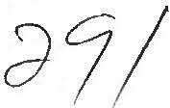Task/Program:

Date and Time of Analysis: Type of Analysis:

Number of Repeats: Cassette Number:

BCU/DIPSLAG 5/23/2009 5:30:22

Concentration Analysis

1

6

Sample Name:

RS2

Sample Number:

RS2

Run Avg>

CuKal,2 2.9701

PbLbla 0.2217

ZnKal,2a 1.0048

AsKbl,3 0.6537

FeKal,2

33.9179

SiKal,2 20.0351

CaKal,2a 1.7519

SKal,2a 4.8844

Task/Program:

Date and Time of Analysis: Type of Analysis:

Number of Repeats: Cassette Number:

AGDIK/RS 5/23/2009 5:31:58

Intensity Measurement

1

6

Sample Name:

RS2

Sample Number:

RS2

Run Avg>

AlKal,2 4.8486

MgKal,2 4.9224

Task/Program:

Date and Time of Analysis: Type of Analysis:

Number of Repeats: Cassette Number:

HCR/HCR

5/23/2009 5:33:20

Concentration Analysis

1

5

Sample Name:

Run SiKal,2 Avg> 32.4796

RSOl

Sample Number:

RS02

Task/Program:

Date and Time of Analysis: Type of Analysis:

Number of Repeats: Cassette Number:

HCR/HCR

5/23/2009 5:33:56

Concentration Analysis

1

6





AgGe alloy contains about 1.2% germanium, and any blots appearing on the surface of the alloy can be easily wiped with wet sponge. AgGe alloy with high hardness and strong crumpling resistance can be used to make large-scale silver ware, special castings and gold solder during the process of jewel and jade. PtGe halide can be used as catalyst during the process of petroleum refining, and PtGe alloy can acted as cracking catalyst.

* + 1. **Analyses of germanium products imports and exports statistics analysis**

1. **Analysis of China germanium metal exports statistics**

O!inese gerrraniummetalrmnthly export volurres in 2007 and 2008

8000

7000

6000

-

-1---

5000

.·.c..: 4000

:::, 3000

2000

1000

0

-

-

f-

-

L- - f-

'--

-

-

1---

-

-

f-

- f-

,_

-

1---

....

-

--

-

f-

f-

f-

f-

;_

f-

f-

f-

-

-

-

-

-

-

-

Jan Feb

f-

-

-

f-

f-

-

l\tar P9r l\tay Jun Jul A.lg Sep Oct Nov Dec

J □ 2001o 2ooa J

( Source: China Customs)

China exported 48,146 kilos of gennanium in 2008, 10% down compared with that in 2007. The export volumes dropped sharply since October 2008, down by around 46%, 50% and 74% respectively in October, November and December 2008, compared with the same period in 2007, because economic crisis broke out in October, and most consumers held a wait-and-see attitude in August and September due to falling price.

44



..

Task/Program:

Date and Time of Analysis: Type of Analysis:

Number of Repeats: Cassette Number:

BCU/DIPSLAG 5/23/2009 21:29:34

Concentration Analysis

1

5

Sample Name: RSl Sample Number: RSl

Run Avg>

CuKal,2 1.4798

PbLbla 0.1776

ZnKal,2a 1.1052

AsKbl,3 0.5275

FeKal,2 31.3053

SiKal,2 24.0175

CaKal,2a 4.4120

SKal,2a 3.6232

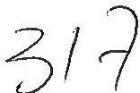Task/Program:

Date and Time of Analysis: Type of Analysis:

Number of Repeats: Cassette Number:

BCU/DIPSLAG 5/23/2009 21:31:34

Concentration Analysis

1

6

Sample Name:

RS2

Sample Number:

RS2

Run Avg>

CuKal,2 1.4658

PbLbla

0.1768

ZnKal,2a 1.0980

AsKbl,3 0.5183

FeKal,2 31.2204

SiKal,2 24.0605

CaKal,2a 4.3794

SKal,2a

3. 6366

Task/Program:

Date and Time of Analysis: Type of Analysis:

Number of Repeats: Cassette Number:

AGDIK/RS

5/23/2009 21:33:08

Intensity Measurement

1

6

Sample Name:

RS2

Sample Number:

RS2

Run Avg>

AlKal,2

5. 2871

MgKal,2

5. 6294

Task/Program:

Date and Time of Analysis: Type of Analysis:

Number of Repeats:

Cassette Number:

HCR/HCR

5/23/2009 21:45:26

Concentration Analysis

1

s

Sample Name:

Run SiKal,2 Avg> 35.4282

RSOl

Sample Number:

RS02

Task/Program:

Date and Time of Analysis: Type of Analysis:

Number of Repeats: Cassette Number:

HCR/HCR

5/23/2009 21:45:52

Concentration Analysis

1

6



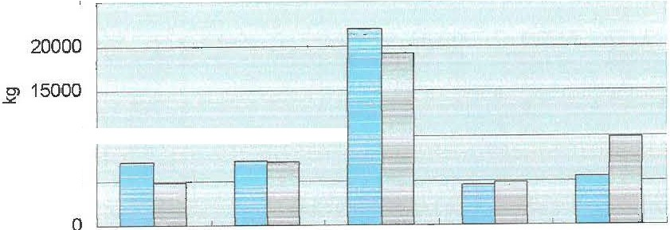

China germanium metal export wlumes bycountry in 2007 and 2008

25000

.....

10000 1 l

5000

Japan

Belgium

Germany

ID 2007 □ 20081

Russia

.America

(Source: China Customs)

Chinese germanium metal were mainly exported to Germany in 2008, accounting for 40% of the total export volumes, next came America and Belgium, respectively around 20% and 15%. China's export volume to Germany was down by around 12% in 2008 compared with that in 2007, down 4% to Belgium, but up 78% to America.

# Analysis of Japan germanium products custom statistics

* 1. **Analysis of Japan germanium oxide import statistics**

Japanese genmaium dioxide ifll)ort volurres inJan-Nov *'2f:JJ7* **and**2008

6000 -

5000

-

4000

,

-

,

Cl

±:: 3000

C

:::::> 2000

-"'

-,

-

I--

-,

,

-

-..

-

=-

,_

,_

- -

L-

L...

I--

1000

0

,

,

I--

I--

=--

,

,

,_-

-

,

,_ ,_

,_

,

H

,

1:;

,

L!

Jan Feb I\Jbr /lpr May Jun Jul tll.lg Sep Oct Nov

j□*2001* □2ooa j

(Source: Japan Customs)

Japan imported 29,207 kilos of germanium oxide from January to November in 2008, 30% down compared with that in 2007. The price dropped further after Chinese government started to impose export tax, but the purchasing quantities decreased as Japanese consumers were reluctant to make purchases at higher prices.

Asian 1v eta1 Leo All nonr<; re ,erve 1e1 -t-CSO IJOl:IUCSUUlt1££ j44

Task/Program:

Date and Time of Analysis: Type of Analysis:

Number of Repeats: Cassette Number:

BCU/DIPSLAG 5/23/2009 19:39:16

Concentration Analysis

1

5

Sample Name:

RSl

Sample Number:

RSl

Run Avg>

CuKal,2 1.3070

PbLbla 0.1843

ZnKal,2a 1.1627

AsKbl,3 0.5819

FeKal,2 31.4532

SiKal,2 25.2558

CaKal,2a 5.4399

SKal,2a 3.0875

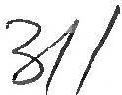

Task/Program:

Date and Time of Analysis: Type of Analysis:

Number of Repeats:

Cassette Number:

BCU/DIPSLAG 5/23/2009 19:41:16

Concentration Analysis

1

6

Sample Name: RS2 Sample Number: RS2

Run Avg>

CuKal,2 1.3613

PbLbla 0.1906

ZnKal,2a 1.1638

AsKbl,3 0.6086

FeKal,2 31.3713

SiKal,2 24.2349

CaKal,2a 5.1361

SKal,2a 3.3566

Task/Program:

Date and Time of Analysis: Type of Analysis:

Number of Repeats: Cassette Number:

AGDIK/RS 5/23/2009 19:42:52

Intensity Measurement

1

6

Sample Name: RS2 Sample Number: RS2

Run Avg>

AlKal,2 4.7747

MgKal,2 5.2314

-"'man Metal Ltd All nonts reserveo. Tel. +86-10 5908u011/22/33/4

# Market forecast

* + - 1. **Factors against price rising**

With the economic crisis spreading across the world, automobile industry has been heavily effected, which leads to a decline of demand for germanium used in civil infrared optical industry; Some suppliers having panic sentiment may cause the price to keep dropping; The demand from downstream market consumers may keep weak as they have a lack of confidence in the future market, resulting in the price falling further.

# Factors contributing to price rising

China's Ministry of Industry and Information says the total public investment expenditure in 3G will reach to around 1.8-2 trillion Yuan during the following three years, which is very significant to cope with a financial crisis, and stimulate economic growth, and is also positive news for germanium market recovering. The demand for germanium in military infrared realm may continue to be strong. The demand for germanium single crystal used in solar energy may go up with the increasing financial investment in this new energy source. Producers may reduce production when demand is weak, which will back up the

price.

Asian Merai Lto *N,* nonts reservea Tei- +-86-10-590800I *122* 334

Task/Program:

Date and Time of Analysis: Type of Analysis:

Number of Repeats:

BGY:/Dt'pgI,,i\,G

5/23/2009 18:52:34



Concentration Analysis

1

Cassette Number: **3 Production situation in ahina**

Sample Name: RSl Sample Number: RSl

**-----------------unrr:-tons--------------------------------------------------------------------------------**

|  |  |  |  |
| --- | --- | --- | --- |
| rltf:ru:Ju Kal, 2a AsKbl,3 F1 | r9i *I* qutpyt*a | **Q4 Q!HR!l** 2, | **TQ! qut:PjJtS in 2008** |
| 2GemianiJmm{jBe 0.6456 31 | ·'M_(il 24.6 | .4 5. 4881 | 36.2-1884 |
| Germanium metal | **10.9** | **8.8** | 37.7 |
| Germanium nomocrystalline | **3.4{R]** | 3.4 | **12.4** |

Run CuKal,2 Pl

Avg> 1. 7096 0

Task/Program: (Notes: Germanium oxide ai"l» en converted to germanium metal volumes; R Date and Time of Analy is· 5/23L2g 9 18:54:36

*3,vI*

Type of Analysis :means mafthe date has beeri:Ht i:! 'tr'ation Analysis

Number of Repeats: 1

Cassette Number: 6

China produced 86.3 tons of germanium products in 2008, but consumers chose to wat

sample Name: the l<et inthe fourth quarter-!!BeEtott"' omic crisf§,2without too many purchases in the spot market, so germanium oxide output decreased in the fourth quarter.

Run CuKal,2

Avg> 1. 694 0

PbLbla ZnKal,2a AsKbl,3 FeKal,2 SiKal,2 CaKal,2a SKal,2a 0.2164 1.1662 0.6446 31.4411 24.5656 5.3362 3.2505

# Germanium applications

* 1. **Germanium oxide used as a catalyst in producing PET bottles**

Task/Program: Germanium oxide, used as afJn1fn lyst, is mainly exported to Japan. It is reported that Date and Time of Japaoesie,customers may uS2-'antlm:any trtoxideliastead of germanium oxide. However,

;:e f 1n; : :9hinese insiders think that !R efWtaeef'tie'htucatl'rliBf be achieved in a short time as

0

cassette Number: antimony trioxide catalyst cou4o release hazardous substances when heated.

Sample Name: RS2 Sample Number: RS2

# ----------------- .2-0ermanic1etrachtoride"ased-irrfiber-optic-communication----------------------------------

Run AlKal, 2 Mgifai!?rf-optic communication is the foundation of the information age. Optical grade

Avg> 4.627 s 4 nium tetrachloride ( i.e., high purity germanium tetrachloride) had been developed

since 1973 in order to meet the need of fiber-optic production. Germanium used in fiber-optic communication mainly seives as fiber-optic and photoelectric conversion. As the operating wavelength of fiber-optic communication should be within the infrared range,

Task/Program: aermanium-doped silica fibllf Uts-t rded to he the best when considering the

Date and Time of 'Analysis: 12 2'oo1'9- 18:59:14

Type of Analysis :performance (refractive indelt.o6e@ffit:ieflt5olilf **a sm)** after the research of all other

Number of Repbeat8extra-long wave infrared fibeil:.optic materials. ln terms of performance parameters, such Cassette Num er: 3

as loss coefficients, the superiority of the germanium-doped silica fiber cannot be matched.

Sampl-e Name:---- Germa lllm_ tetrachloride_is s aeffiff1qf,r be the _best materials _used _in fiber-opJic ­

communication.

Run CuKal,2a AsKbl,3 PbLbla SKal,2a ZnKa1,2a FeKal,2 AgKal,2

Avg> 45.0791 0.4659 0.5742 25.3061 0.6592 27.9525 0.0181

With the copper price rising while optical fiber price dropping, optical fiber cable has an incomparable advantage compared with copper cable in the aspect of transmission speed

and transmission capability, so it may be a new substitute, which will bring g ·-

Task/ p rag ram: opportunities for optical fiber B ajWJ:i§lry. ***//Ji***

Date and Time of Analysis: 5/23/2009 19:01:46 V

Type of Analysis: Concentration Analysis Number of Repeats4-3 **Germanium metal used in infrared optical sector**

Cassette Number: Germanium metal is wildly dsed in infrared optical sector, mainly applied to national Sample Name: CM02 Sample Number:

Run CuKa1,2a AsKbl,3 PbLbla SKal,2a ZnKal,2a FeKal,2 AgKal,2

Avg> 44.9223 0.4600 0.5705 25.6394 0.6570 27.8630 0.0181

Task/Program:

Date and Time of Analysis: Type of Analysis:

Number of Repeats:

BCU/DiPSLAG

5/23/2009 18:52:34

Concentration Analysis

1

Cassette Number: **3 Production situation in ahina**

Sample Name: RSl Sample Number: RSl

u-n . tons

|  |  |  |  |
| --- | --- | --- | --- |
| rlff:PJ1uo.!%Kal, 2a AsKbl 3 FE **K9tC¥JtP l a** | | **,Q4 'NtR!llp** 2, | **Tq! qutwts in 2008** |
| 2GermaniJm1cixl8e 0.6456 31 | ·f{t l 24.6 | -4 5. 4881 | 36.2-1884 |
| Germanium metal | 10.9 | **8.8** | 37.7 |
| Germanium nomocl)fstalline | **3.4[R]** | **3.4** | **12.4** |

Run CuKal,2 Pl

Avg> 1.7096 0 •

Task/Program: (Notes: Germanium oxide O\llt:J!)\JtDf:l en converted to germanium metal volumes; R

Date and Time of Analy&is: 5/2312 9 18:54:36

th

Type of Analysis :means mat e date hasbeercf.i'l:l 'tr'ation Analysis *{*

Number of Repeats: 1

Cassette Number: 6

China produced 86.3 tons of germanium products in 2008, but consumers chose to wat

sample Name: the rmirl<et in the fourth quartel3-!!8Moru=i@ omic crisi§;2without too many purchases in the spot market, so germanium oxide output decreased in the fourth quarter.

Run CuKal,2

Avg> 1.6940

PbLbla ZnKal,2a AsKbl,3 FeKal,2 0.2164 1.1662 0.6446 31.4411

# Germanium applications

SiKal,2 CaKal,2a SKal,2a 24.5656 5.3362 3.2505

# Germanium oxide used as a catalyst in producing PET bottles

Task/Program: Germanium oxide, used as afc§1f?\\ lyst, is mainly exported to Japan. It is reported that Date and Time of Japanese, customers may USiVaatt01D11¥ 1rirncieelinstead of germanium oxide. However,

Type of Analysis :Ghinese insiders think that :.Ree&diaeern'e'tilucarMBf be achieved in a short time as Number of Repeats. f

cassette Number: antimony trioxide catalyst coufd release hazardous substances when heated.

Sample Name: RS2 Sample Number: RS2

# ----------------.t.2-Germanicietrachloride-ased-irrfiber-optic-communicatiorr----------------------------------

Run AlKal, 2 Mgifaip f-optic communication is the foundation of the information age. Optical grade

Avg> 4.627 8 4 anium tetrachloride (i.e., high purity germanium tetrachloride) had been developed since 1973 in order to meet the need of fiber-optic production. Germanium used in fiber-optic communication mainly seJVes as fiber-optic and photoelectric conversion. As the operating wavelength of fiber-optic communication should be within the infrared range,

Task/Program: aermanium-doped silica fib/;lFU /rrted to be the best when considering the Date and Time of nalysis: S/2 i 'I8:59:14

Type of Analysis :performance (refractive inde 6eeffic&ttsoraf **a9sirut)** after the research of all other

Numbertof Repbeatsextra-long wave infrared fiberloptic materials. In terms of performance parameters, such Casset e Num er: ':3

as loss coefficients, the superiority of the germanium-doped silica fiber cannot be matched.

sample_Name: Germ 'r\fllm_ tetrachloride_is s cle 1tor be the _best materials _used _in fiber-o_pJic _

communication.

Run CuKal,2a AsKbl,3 PbLbla SKal,2a ZnKal,2a FeKal,2 AgKal,2

Avg> 45.0791 0.4659 0.5742 25.3061 0.6592 27.9525 0.0181

With the copper price rising while optical fiber price dropping, optical fiber cable has an

incomparable advantage compared with copper cable in the aspect of transmission speed and transmission capability, so it may be a new substitute, which will bring g

Task/Program: opportunities for optical fiber § aj try. **#i**

Date and Time of Analysis: 5/23/2009 19:01:46 **V**

Type of Analysis: Concentration Analysis Number of Repeatsll:.3 **Germanium metal used in infrared optical sector**

cassette Number: Germanium metal is wildly dsed in infrared optical sector, mainly applied to national Sample Name: CM02 Sample Number:



Run CuKal,2a AsKbl,3 PbLbla SKal,2a ZnKal,2a FeKal,2 AgKal,2

Avg> 44.9223 0.4600 0.5705 25.6394 0.6570 27.8630 0.0181

AS1an MeTal ua. All nants reservea. Tei: +86- i0-590800 11/22/-53/44

# Market forecast

* 1. **Factors against price rising**

With the economic crisis spreading across the world, automobile industry has been heavily effected, which leads to a decline of demand for germanium used in civil infrared optical industry; Some suppliers having panic sentiment may cause the price to keep dropping; The demand from downstream market consumers may keep weak as they have a lack of confidence in the future market, resulting in the price falling further.

* 1. Factors contributing to price rising

China's Ministry of Industry and Information says the total public investment expenditure in 3G will reach to around 1.8 2 trillion Yuan during the following three years, which is very significant to cope with a financial crisis, and stimulate economic growth, and is also positive news for germanium market recovering. The demand for germanium in military infrared realm may continue to be strong. The demand for germanium single crystal used in solar energy may go up with the increasing financial investment in this new energy source. Producers may reduce production when demand is weak, which will back up the

price.

Task/Program:

Date and Time of Analysis: Type of Analysis:

Number of Repeats: Cassette Number:

BCU/DIPSLAG 5/23/2009 19:39:16

Concentration Analysis 1

5

Sample Name:

RSl

Sample Number:

RSl

Run Avg>

CuKal,2

1.3070

PbLbla

0.1843

ZnKal,2a 1.1627

AsKbl,3

0.5819

E'eKal,2 31.4532

SiKal,2 25.2558

CaKal,2a

5.4399

SKal,2a

3.0875

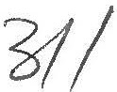

Task/Program:

Date and Time of Analysis: Type of Analysis:

Number of Repeats:

Cassette Number:

BCU/DIPSLAG 5/23/2009 19:41:16

Concentration Analysis

1

6

Sample Name: RS2 Sample Number; RS2

Run Avg>

CuKal,2 1.3613

PbLbla 0.1906

ZnKal,2a

1.163B

AsKbl,3

0.6086

FeKal,2

31.3713

SiKal,2 24.2349

CaKal,2a 5.1361

SKal,2a 3.3566

Task/Program:

Date and Time of Analysis: Type of Analysis:

Number of Repeats: Cassette Number:

AGDIK/RS 5/23/2009 19:42:52

Intensity Measurement

1

6

Sample Name: RS2 Sample Number: RS2

Run Avg>

AlKal,2 4.7747

MgKal,2 5.2314

'•



,er +tso IU Ol:/UtsUOI l'LL/jj 44

|  |  |  |  |  |  |
| --- | --- | --- | --- | --- | --- |
| 25000 |  | | | | |
| 20000 |  |  |  |  |  |
| 15000 |  |  |  |  |  |
| :3 10000 |  |  |  |  |  |
| 5000 |  |  |  |  |  |
| 0 | China | Finland | Russia | Canada | Pmerica |

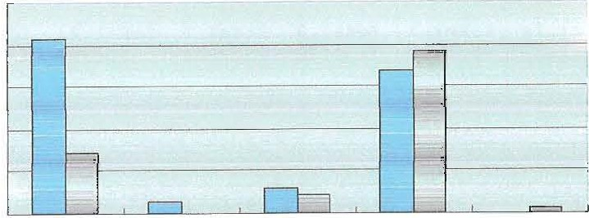( Source: Japan Customs)

Japanese germanium dioxide export \Olumes bycountryin Jan-Nov

2007 and 2008

I□Jan-Nov, 2007 □Jan-Nov, 20081

Japan reduced the purchasing quantities from China to only 7,229 kilos of germanium oxide in Jan-Nov, 2008, down by around 65% compared with that in the same period in 2007. Germanium oxide imported from Canada was up by around13%. Moreover, Japan purchased materials from America in 2008, instead of Finland.

# Analysis of Japan gennanium metal import statistics

Japanese germanium metal import -.olumes by month in 2008

1200

1000

0) 800

-""

+-' 600

C:

::>

400

200

0

Jan Feb Mar Apr May Jun Jul Aug Sep Oct Nov

( Source: Japan Customs)

Japan imported 6,072 kilos of germanium metal from January to November in 2008, with the import volumes from China and America accounting for 89% and 9% respectively of Japan's total import volume. Organic germanium and germanium accessories were very popular in Japan in 2005 and 2006, but not so prevailing recently; the demand for germanium oxide from solar battery may increase, and now Japanese Fuji Electric Systems Co., Ltd is doing researching into SiGe non-crystal film solar cell.

Task/Program:

Date and Time of Analysis: Type of Analysis:

Number of Repeats: Cassette Number:

BCU/DIPSLAG 5/23/2009 20:56:18

Concentration Analysis

1

5

Sample Name:

RSl

Sample Number:

RSl

Run CuKal,2 Avg> 2.0900

PbLbla 0.2081

ZnKal,2a 1.0242

AsKb1,3 0.5723

FeKal,2 31.5399

SiKal,2 20.0958

CaKal,2a 2.2858

SKal,2a 4.8951

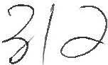

Task/Program:

Date and Time of Analysis: Type of Analysis:

Number of Repeats: Cassette Number:

BCU/DIPSLAG 5/23/2009 20:58:18

Concentration Analysis

1

6

Sample Name:

RS2

Sample Number:

RS2

Run CuKal,2 Avg> 2.1225

PbLbla 0.2118

ZnKal,2a 1.0242

AsKbl,3 0.5881

FeKal,2 31.4529

SiKal,2 19.3820

CaKal,2a 2.0445

SKal,2a 5.1016

Task/Program:

Date and Time of Analysis: Type of Analysis:

Number of Repeats: Cassette Number:

AGDIK/RS

5/23/2009 20:59:54

Intensity Measurement

1

6

Sample Name: RS2 Sample Number: RS2

Run Avg>

AlKal,2 4.9358

MgKal,2 5.4406

Task/Program:

Date and Time of Analysis: Type of Analysis:

Number of Repeats: Cassette Number:

HCR/HCR

5/23/2009 21:01:34

Concentration Analysis

1

5

Sample Name:

Run SiKal,2 Avg> 34.5283

RSOl

Sample Number: RS02

Task/Program:

Date and Time of Analysis: Type of Analysis:

Number of Repeats: Cassette Number:

HCR/HCR

5/23/2009 21:02:06

Concentration Analysis

1

6

an 1V1etat Lto A! •tams reservea tet 00 U ')l:fUOUU t t /*L.,t.l***,j,j/44**

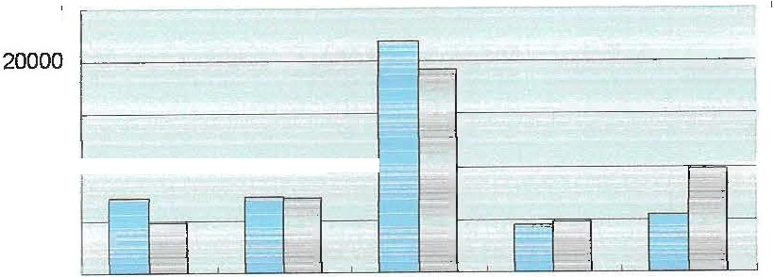

China germanium metal exportvulumes bycountryin 2007 and 2008

25000

*J2* 15000

10000 1 l

5000

0

Japan Belgium Germany

Russia

America

1□ *2001* □ 20081

( Source: China Customs)

Chinese germanium metal were mainly exported to Germany in 2008, accounting for 40% of the total export volumes, next came America and Belgium, respectively around 20% and 15%. China's export volume to Germany was down by around 12% in 2008 compared with that in 2007, down **4%** to Belgium, but up 78% to America.

# Analysis of Japan germanium products custom statistics

* + 1. **Analysis of Japan germanium oxide import statistics**



Japanese gerrmaium dioxide irrport volurres inJan- v '2f!J7and 2008

-=""

C:

6000

5000

4000

-

1-------r1--------l f---

3000 <---

-

1-11:=:--I-

-

-

I-

::::> 2000

1000

0

.

L-

. ,-

L,

'-

C-

L-

I.J

Jan Feb 11/'ar Jl{Jr 1\/'ay Jun Jul Aug Sep Oct Nov

Io *2001* □2oos J

(Source: Japan Customs)

Japan imported 29,207 kilos of germanium oxide from January to November in 2008, 30% down compared with that in 2007. The price dropped further after Chinese government started to impose export tax, but the purchasing quantities decreased as Japanese consumers were reluctant to make purchases at higher prices.

Task/Program:

Date and Time of Analysis: Type of Analysis:

Number of Repeats:

cassette Number:

BCU/DIPSLAG 5/23/2009 21:29:34

Concentration Analysis

1

5

Sample Name:

RSl

Sample Number:

RSl

Run Avg>

CuKal,2 1.4798

PbLbla 0.1776

ZnKal,2a 1.1052

AsKbl,3 0.5275

FeKal,2 31.3053

SiKal,2 24.0175

CaKal,2a 4.4120

SKal,2a 3.6232

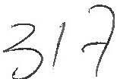Task/Program:

Date and Time of Analysis: Type of Analysis:

Number of Repeats:

Cassette Number:

BCU/DIPSLAG 5/23/2009 21:31:34

Concentration Analysis

1

6

Sample Name:

RS2

Sample Number:

RS2

-

Run Avg>

CuKal,2 1.4658

PbLbla 0.1768

ZnKal,2a 1.0980

AsKbl,3 0.5183

FeKal,2 31.2204

SiKal,2 24.0605

CaKal,2a 4.3794

SKal,2a 3.6366

Task/Program:

Date and Time of Analysis: Type of Analysis:

Number of Repeats: Cassette Number:

AGDIK/RS

5/23/2009 21:33:08

Intensity Measurement

1

6

Sample Name:

RS2

Sample Number:

RS2

Run Avg>

AlKal,2 5.2871

MgKal,2 5.6294

Task/Program:

Date and Time of Analysis: Type of Analysis:

Number of Repeats: Cassette Number:

HCR/HCR

5/23/2009 21:45:26

Concentration Analysis

1

5

Sample Name: RSOl Sample Number: RS02

Run SiKal,2 Avg> 35.4282

Task/Program:

Date and Time of Analysis: Type of Analysis:

Number of Repeats: Cassette Number:

HCR/HCR

5/23/2009 21:45:52

Concentration Analysis

1

6



I I

AgGe alloy contains about 1.2% germanium, and any blots appearing on the surface of the alloy can be easily wiped with wet sponge. AgGe alloy with high hardness and strong crumpling resistance can be used to make large-scale silver ware, special castings and gold solder during the process of jewel and jade. PtGe halide can be used as catalyst during the process of petroleum refining, and PtGe alloy can acted as cracking catalyst.

1. **Analyses of gennanium products imports and exports statistics analysis**
   1. **Analysis of China germanium metal exports statistics**

Chinese gerrraniummetal rronthly export volurras in 2007 and 2008

8000

7000

6000

-

-

-,_

'----

o, 5000

..>t!

·..c..; 4000

::i 3000

2000

1000

0

--

' .,._

-

-

- f--- -

I- -

I--

-

I-

,_

-

-

-

f--- I-

I-

-I--

I-

I-

-

·-

-

f--- f---

-

I--

I-- ,1---

-,_

-

I--

1--

,_

-·

-

- -

-· I---

I--

.

Jan Feb llfar Ppr llfay Jun Jul Aug Sep Oct Nov Dec

J □ *2001* □2oos J

(Source: China Customs)

China exported 48,146 kilos of germanium in 2008, 10% down compared with that in 2007. The export volumes dropped sharply since October 2008, down by around 46%, 50% and 74% respectively in October, November and December 2008, compared with the same period in 2007, because economic crisis broke out in October, and most consumers held a wait-and-see attitude in August and September due to falling price.

Task/Program:

Date and Time of Analysis: Type of Analysis:

Number of Repeats: Cassette Number:

BCU/DIPSLAG

5/23/2009 5:28:20

Concentration Analysis

1

5

Sample Name:

RSl

Sample Number:

RSl

Run

Avg>

CuKal,2

2.9774

PbLbla

0.2237

ZnKal,2a 0.9910

AsKbl,3

0.6671

FeKal,2

33.9023

SiKal,2

19.5654

CaKal,2a

1.4903

SKal,2a

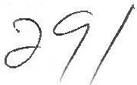5.0477

Task/Program:

Date and Time of Analysis: Type of Analysis:

Number of Repeats:

Cassette Number:

BCU/DIPSLAG 5/23/2009 5:30:22

Concentration Analysis

1

6

Sample Name: RS2 Sample Number: RS2

Run

Avg>

CuKal,2

2.9701

PbLbla

0.2217

ZnKal,2a

1.0048

AsKbl,3

0.6537

FeKal,2

33.9179

SiKal,2 20.0351

CaKal,2a

1.7519

SKal,2a

4.8844

Task/Program:

Date and Time of Analysis: Type of Analysis:

Number of Repeats: Cassette Number:

AGDIK/RS 5/23/2009 5:31:58

Intensity Measurement

1

6

Sample Name:

RS2

Sample Number:

RS2

Run

Avg>

AlKal,2 4.8486

MgKal,2

4.9224

Task/Program:

Date and Time of Analysis: Type of Analysis:

Number of Repeats: Cassette Number:

HCR/HCR

5/23/2009 5:33:20

Concentration Analysis

1

5

Sample Name:

RSOl

Sample Number: RS02

Run SiKal,2

Avg> 32.4796

Task/Program:

Date and Time of Analysis: Type of Analysis:

Number of Repeats: Cassette Number:

HCR/HCR

5/23/2009 5:33:56

Concentration Analysis

1

6

I n I 11:'tal L O /-IJ

defense equipments. The atmospheric transmissivity of germanium is high and homogeneous because it is within the 2~14 micron infrared band where the infrared ray has the highest transparency in the aerosphere. Therefore, it is an irreplaceable infrared optical material. Meanwhile, germanium has lots of prominent dominance, such as chemical stability, corrosion-resistant and easily processed. Germanium could be made into germanium single crystal, and sliced up to make germanium lens and germanium windows. Germanium single crystal could be made into infrared optical components because of the characteristic of long wavelength when permeating infrared optical, which is wildly used in all kinds of infrared optical system, such as thermal infrared imager and night-vision goggles, photo detector, infrared detectors, missiles, lasers, infrared radar microwave tubes and microwave integrated circuits.

In the aspect of germanium used in national defense equipments, the demand for germanium depends on the update of national defense equipment, and may increase with the update term arriving.

**4.4 Germanium single crystal used in solar cell industry**

With the unique trait of high radioresistance, high frequency, good photoelectric properties, high purity germanium single crystal is wildly used in the high-tech fields, such as energy sources, photoelectricity, national defense, aviation and IT industry. Compound semiconductors on germanium substrate battery with its trait of high efficiency, high voltage, and high temperature has been wildly used in satellite solar cell, radar station for national defense in remote and border areas and microwave communication stations.

After Si, GaAs, lnP solar battery, I11-V compound thin-film epitaxially grown on germanium substrate solar cells (namely ( GalnP/GaAs/Ge) monocrystalline thin-film three-junction solar cell) is the fourth generation product whose highest photoelectric conversion efficiency could achieve 28%-32% under industrialization, and the germanium monocrystalline with dislocation density (::;;103/cm2) is the major substrate material to produce satellite solar cell. It is reported that with the development of photoelectric conversion efficiency of germanium monocrystalline used in solar battery, solar energy photovoltaic field becomes another growing market where germanium could be applied to.

**4.5 Germanium used in new technology fields**

SiGe compound has been applied to CMOS chips and transistors because it makes CMOS chips and transistors smaller, reduces electronic noise produced by themselves, extends battery life, and assures stability under the extra HF condition. IBM has announced that they have produced SiGe chips operating at room temperature with frequency nearly 350GHz. In the areas of wireless communication, we have substituted SiGe compound for GaAs; Si chips producers have produced low cost and industrialized SiGe chips. Scientists are now doing research into the germanium insulating substrate material which can replace silicon metal in a small chips and LED products based on germanium.

Task/Program:

Date and Time of Analysis: Type of Analysis:

Number of Repeats: Cassette Number:

BCU/DIPSLAG 5/22/2009 23:47:16

Concentration Analysis

1

5

Sample Name:

RSl

Sample Number:

RS1

Run CuKal,2 Avg> 1.5885

PbLbla 0.1851

ZnKal,2a 1.1533

AsKbl,3 0.5687

FeKal,2 35.7551

SiKal,2 29.0427

CaKal,2a 5.0198

SKal,2a 1.9404

Task/Program:

Date and Time of Analysis: Type of Analysis:

Number of Repeats: Cassette Number:

BCU/DIPSLAG 5/22/2009 23:49:16

Concentration Analysis

1

6

Sample Name:

RS2

Sample Number:

RS2

Run Avg>

CuKal,2 1.6139

PbLbla 0.1883

ZnKal,2a 1.1711

AsKbl,3 0.5773

FeKal,2 35.6831

SiKal,2 28.9477

CaKal,2a 5.2193

SKal,2a 1.9002

Task/Program:

Date and Time of Analysis: Type of Analysis:

Number of Repeats: Cassette Number:

AGDIK/RS

5/22/2009 23:50:50

Intensity Measurement

1

6

Sample Name: RS2 Sample Number: RS2

Run Avg>

AlKal,2 4.8802

MgKal,2 5.5550

Task/Program:

Date and Time of Analysis: Type of Analysis:

Number of Repeats: Cassette Number:

BCU/MATTE 5/22/2009 23:53:44

Concentration Analysis

1

3

Sample Name:

CMOl

Sample Number:

Run Avg>

CuKal,2a 51.9674

AsKbl,3 0.4675

PbLbla 0.5897

SKal,2a 23.7729

ZnKal,2a 0.5580

FeKal,2 21.3570

AgKal,2 0.0227

Task/Program:

Date and Time of Analysis: Type of Analysis:

Number of Repeats: Cassette Number:

BCU/MATTE 5/22/2009 23:56:14

Concentration Analysis

1

*4*

Sample Name: CM02 sample Number:

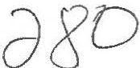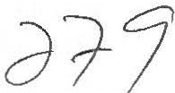Run Avg>

CuKal,2a 52.0510

AsKbl,3

0. 47 64

PbLbla 0.5913

SKal,2a 23.6454

ZnKal,2a 0.5574

FeKal,2 21.3272

AgKal,2 0.0228

n 1vierni ta Ali nahts rese--ved Tel +86 10 59080011t22i3-l144

1. **Production situation in China**

Unit: tons

|  |  |  |  |
| --- | --- | --- | --- |
| Products | Q3 outputs | Q4 outputs | Total outputs in 2008 |
| Germanium oxide | **10.1** | 9.4 | **36.2** |
| Germanium metal | **10.9** | **8.8** | **37.7** |
| Germanium nomocrystalline | **3.4{R]** | **3.4** | **12.4** |

CNotes: Germanium oxide output have been converted to germanium metal volumes; R means that the date has been revised.)

China produced 86.3 tons of germanium products in 2008, but consumers chose to watch the market in the fourth quarter due to the economic crisis, without too many purchases in the spot market, so germanium oxide output decreased in the fourth quarter.

1. **Germanium applications**
   1. **Germanium oxide used as a catalyst in producing PET bottles**

Germanium oxide, used as a PET catalyst, is mainly exported to Japan. It is reported that Japanese customers may use antimony trioxide instead of germanium oxide. However, Chinese insiders think that the replacement cannot be achieved in a short time as antimony trioxide catalyst could release hazardous substances when heated.

* 1. **Germanic tetrachloride used in fiber-optic communication**

Fiber-optic communication is the foundation of the information age. Optical grade germanium tetrachloride (i.e., high purity germanium tetrachloride) had been developed since 1973 in order to meet the need of fiber-optic production. Germanium used in fiber-optic communication mainly serves as fiber-optic and photoelectric conversion. As the operating wavelength offiber-optic communication should be within the infrared range, germanium-doped silica fiber is regarded to be the best when considering the performance (refractive index, coefficients of expansion) after the research of all other extra-long **wave** infrared fiber-optic materials. In terms of performance parameters, such as loss coefficients, the superiority of the germanium-doped silica fiber cannot be matched. Germanium tetrachloride is considered to be the best materials used in fiber-optic communication.

With the copper price rising while optical fiber price dropping, optical fiber cable has an incomparable advantage compared with copper cable in the aspect of transmission speed and transmission capability, so it may be a new substitute, which will bring great opportunities for optical fiber cable industry.

* 1. **Germanium metal used in infrared optical sector**

Germanium metal is wildly used in infrared optical sector, mainly applied to national

Task/Program;

Date and Time of Analysis:

Type of Analysis: Number of Repeats: Cassette Number:

BCU/DIPSLAG 5/23/2009 1:26:20

Concentration Analysis

1

5

Sample Name: RSl Sample Number: RSl

Run Avg>

CuKal,2 2.2475

PbLbla 0.2046

ZnKal,2a 1.0744

AsKbl,3 0.6075

FeKal,2 35.1504

SiKal,2 23.3779

CaKal,2a 2.8481

SKal,2a 3.7116

Task/Program:

Date and Time of Analysis: Type of Analysis:

Number of Repeats: Cassette Number:

BCU/DIPSLAG 5/23/2009 1:28:20

Concentration Analysis

1

6

Sample Name:

RS2

Sample Number:

RS2

Run Avg>

CuKal,2 2.2526

PbLbla 0.2023

znKal,2a 1.0655

AsKbl,3 0.6161

FeKal,2 35.1042

SiKal,2 23.3398

CaKal,2a 2.7595

SKal,2a 3.7490

Task/Program:

Date and Time of Analysis: Type of Analysis:

Number of Repeats: Cassette Number:

AGDIK/RS 5/23/2009 1:29:56

Intensity Measurement

1

6

Sample Name:

RS2

Sample Number:

RS2

Run Avg>

AlKal,2 4.9408

MgKal,2 5.2790

Task/Program:

Date and Time of Analysis: Type of Analysis:

Number of Repeats: Cassette Number:

HCR/HCR

5/23/2009 1:30;50

Concentration Analysis

1

5

Sample Name:

Run SiKal,2 Avg> 34.0252

RSOl

Sample Number:

RS02

Task/Program:

Date and Time of Analysis: Type of Analysis:

Number of Repeats: Cassette Number:

Sample Name: RS02

HCR/HCR

5/23/2009 1:31:24

Concentration Analysis

1

6

Sample Number: RS02

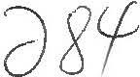

Run SiKal,2 Avg> 34.2429



IeI 01:> , u o::iuouu, 1 i,1;>.:,144

few deals were concluded in the market during the summer holiday in western countries. The market remained inactive in September, when foreign consumers finished their summer vacation and the export price fell to around USD1,560-1,580/kg.

Few deals were concluded in gennanium metal market in the fourth quarter, and the price declined considerably in October and November from USD1,560-1,580/kg to USD1,330-1,350/kg, down by around 15%. The price stayed at the above level in December, and consumers ere holding a wait-and-see attitude while producers were reluctant to lower offers, making the market stagnant.

**2.2 Germanium oxide market review**



Germanium oxide price cur.es in 2008

1200

8000

::)

::)

1000r

800

600

400

200

, --..

C)

7000

6000

5000

4000

Cl

0

--

rn

3000 -'jg

::)

2000

1000

0 0

Jan Feb .Apr !Vay Jul A.lg Sep Nov Dec

China germanium oxide export price -+- China germanium oxide price

(Source: Asian Metal)

Chinese government started to impose 5% export duty on gennanium oxide (HS Code: 28256000) from 1st Jan 2008, so Chinese exporters raised offers from USD870-890/kg to USD930-950/kg at the beginning of January, and kept increasing it to around USD1,030-1,050/kg during April and May though Japanese consumers were unwilling to make purchases at thess high prices.

However, there was increasing germanium oxide supply in the spot market in June. Some Zinc producers were forced to sell germanium oxide inventories as zinc price kept falling, so the supply of gennanium oxide began to increase and the price increase of gennanium dioxide slowed down. The price of zinc 99.995% min was around at the beginning of January, 2008, and from then on it kept dropping and declined to around RMB16,000-16,100/t late May, down by 16% in a period of five months. Some zinc producers increased the sales volume of gennanium oxide to make up the losses.

Germanium oxide price began to fall from USD1, 030-1,050/kg in July, and then, affected by the economic crisis, it dropped to around USD800-820/kg in the middle of November, remaining stable in December as Chinese suppliers were reluctant to lower offers, leaving the market in a stagnant situation.

Task/Program;

Date and Time of Analysis; Type of Analysis:

Number of Repeats: Cassette Number:

BCU/DIPSLAG 5/23/2009 0:37:52

Concentration Analysis

1

5

Sample Name:

RSl

Sample Number:

RSl

Run CuKal,2 Avg> 1.6010

PbLbla 0.1993

ZnKal,2a 1.1432

AsKbl,3 0.6369

FeKal,2 35.3733

SiKal,2 26.7361

CaKal,2a 4.4173

SKal,2a 2.5555

Task/Program:

Date and Time of Analysis: Type of Analysis:

Number of Repeats: Cassette Number:

BCO/DIPSLAG 5/23/2009 0:39:52

Concentration Analysis

1

6

Sample Name:

RS2

Sample Number:

RS2

Run Avg>

CuKal,2 1.5913

PbLbla 0.1976

ZnKal,2a 1.1398

As Kb1, 3

0.6384

FeKal,2 35.3840

SiKal,2 26.9757

CaKal,2a 4.4095

SKal,2a 2.5149

Task/Program:

Date and Time of Analysis: Type of Analysis:

Number of Repeats: Cassette Number:

AGDIK/RS 5/23/2009 0:41:28

Intensity Measurement

1

6

Sample Name: RS2 Sample Number: RS2

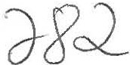Run Avg>

AlKal,2 5.2340

MgKal,2 5.8038





provinces. Germanium reserves in the above provinces take an account of 96% in the total amount.

# Market Review

With global economic crisis spreading across the world from the fourth quarter of 2008, both producers and consumers hold a wait-and-see attitude towards the germanium market. Except for some long-term contracts having been signed before, new orders are seldom sealed. Few inquiries in the market and panic sentiments from participants cause the price to go down, which makes consumers continue to watch the market, which explains why there were few deals in the fourth quarter. The germanium market was deadlocked in December 2008, and the price trend may be clear next year.

# Germanium metal market review

China germanium metal export price - .-- Germanium metal price in Europe Germanium metal price in China

8500

11500

1800

. ·- ·- • I

1600 **L.....** -· ....., 11111 l!I **IMMIIINIIIIINII...** Ill +..i, • _..; 11000

Germanium metal price curves in 2008

l

1111111111111111111111111111Ill llll 11111111llll 1111111lltllWllll1 8000

1-4 2-15 3-21 4-30 6-6 7-11 8-20 9-24 11-5 12-10

400

20

10500 *sf*

10000

9500

9000 ::C,

--

1000 r,

i : f:_

_,,;,,,- .

1400

*i* 1200 1

,

(Source: Asian Metal)

China germanium metal price was relatively stable in the first quarter in 2008 and it rose slightly in March. Germanium metal export price keeps stable at around USD1,300-1,320/kg from January to February, but went up to around USD1,380-1,400/kg late March as some Chinese suppliers increased offers.

Germanium metal price kept rising in the second quarter, eventually up to around USD1,600-1,620/kg in May. The main reasons for the continuous price increase were the tight supply in the market and Chinese suppliers continuing to increase their offers. However, the price remained stable in June, rather than continuously going up, because some zinc producers started to sell germanium dioxide inventories when zinc price began to drop, which helped ease up the supply shortage.

The price began to fall from USD1,600-1,620/kg to USD1,580-1,600/kg in the third quarter, with the offers widely-ranged. Some suppliers even offered as low as USD1,500/kg, since





Task/Program:

Date and Time of Analysis: Type of Analysis:

Number of Repeats: Cassette Number:

BCU/REVSLAG 5/23/2009 0:44:46

concentration Analysis

1

5

Sample Name: RSl Sample Number: RSl

Run CuKal,2 Avg> 1.7224

PbLbla 0.7842

ZnKal,2a 1.1507

AsKbl,3 2.0375

FeKal,2 30.8699

SiKal,2 29.4550

CaKal,2a 2.6075

SKal,2a 3.4930

Task/Program:

Date and Time of Analysis: Type of Analysis:

Number of Repeats: Cassette Number:

BCU/REVSLAG 5/23/2009 0:46:48

Concentration Analysis

1

6

Sample Name:

RS2

Sample Number:

RS2

Run Avg>

CuKal,2 1.7081

PbLbla 0.7737

ZnKal,2a 1.1513

AsKbl,3 2.0123

FeKal,2 30.5901

SiKal,2 29.8542

CaKal,2a 2.6715

SKal,2a 3.3969

Task/Program:

Date and Time of Analysis: Type of Analysis:

Number of Repeats: Cassette Number:

AGDIK/RS 5/23/2009 0:48:24

Intensity Measurement

1

6

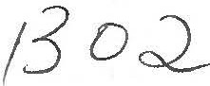Sample Name:

Run AlKal,2 Avg> 11.0239

MgKal,2 10.5143

RS2

Sample Number: RS2





# 2008 Annual Report on Germanium Market 1 Properties, usages, distributions of germanium

* 1. **Germanium properties**

Germanium is a silvery-gray, brittle metal, albeit some people also calling it a semi-metal, which has a bright luster. It was discovered in 1886 by a Germany chemist. Its melting point is at 937.4·c, boiling point at 2830°C and density around 5.35g/cm3•

Germanium is contained with zinc ores, other sulfide ore minerals and coals. The average germanium content in zinc deposits from which it is recovered ranges from 0.01% to 0.1%, while that in coals differs from 0.001% to 0.1%.

# Germanium usages

Germanium used in fiber-optic systems accounts for 24% of the worldwide consumption, polymerization catalysts, 31%; infrared optics, 23%; solar electric applications, 12%; and others (phosphors, metallurgy and chemotherapy), 10%.

However, the situation differs with countries. For example, Japan uses germanium mainly as the polymerization catalysts, white such applications are rare in America, where germanium is mainly consumed in fiber-optic systems (40% of the American consumption), infrared optics (30%) and solar cell applications (20%).

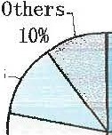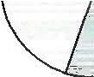

Worldwide germanium consumptions

Fiber optics 24%

Solar cells

12%

Infrared optics

23%

PET catalysts

31%

# Germanium distributions in China

China has a reserve base of 3,055t of germanium, which is spread in eleven provinces and regions, including Guangdong, Yunnan, Jilin, Shanxi, Sichuan, Guangxi and Guizhou



el O IV ,>l1Vl:IVV I I/<! ., 'I